Software Requirements Specification

for

Best Buy Mobile Phone Using Opinion Analytics

Version 2.0

Prepared by:

Zain Ali (FA14-BCS-045)

Semab Ali (FA14-BCS-018)

Supervised by:

Mr. Tanveer Ahmed

Co-supervised by:

Mr. Asif Muhammad

Department of Computer Science,

CIIT, Islamabad.

13/12/2017

**Table of Contents**

Revision History iii

1. Introduction 1

1.1 Purpose 1

1.2 Scope 1

1.2.1 Data Acquisition 1

1.2.2 Pre-processing of Reviews 1

1.2.3 Sentiment Analysis 2

1.2.4 Visualization 2

1.2.5 Product recommendation 3

1.2.6 Seller information 3

2. Use Cases 3

2.1 Use Case Diagram 4

2.2 Use Case Description 6

2.2.1 Search Mobile 6

2.2.2 View Mobile Model 7

2.2.3 Make Comparison 8

2.2.4 View Feature Rating 8

2.2.5 View Seller Information 9

2.2.6 Make Comments 9

2.2.7 Get Mobile Recommendation 10

2.2.8 Send Email 10

2.2.9 Fetch Seller Information 11

2.2.10 Fetch Reviews 11

2.2.11 Fetch Mobile Specifications 12

2.2.12 Store Data 12

2.1 Functionality 13

*2.1.1* Data Acquisition 13

*2.1.2* Classify Data 13

*2.1.3* Rate Features 13

*2.1.4* Visualize Feature 13

*2.1.5* Select Specification 14

*2.1.6* Reset Field 14

*2.1.7* Validation 14

*2.1.8* Query Submission 14

*2.1.9* Process Submitted Query 15

*2.1.10* Query Response 15

2.1.11 Enter Model Name 15

2.1.12 Submit Query 15

2.1.13 Query Processing 16

2.1.14 Display Result 16

2.1.15 Compare Result 16

2.1.16 Validation 16

2.1.17 Compare Records 17

2.1.18 System Response 17

2.1.19 Select Mobile Model 17

2.1.20 Compare Model 17

2.1.21 View Comparison 18

2.1.22 View Model 18

2.1.23 View Specs 18

2.1.24 View Feature Rating 18

2.1.25 View Seller Information 19

2.1.26 Add Comment 19

2.1.27 View Comments 19

2.2 Non – Functional Requirements 19

2.2.1 Usability 19

2.2.2 Performance 20

2.2.3 Reliability 20

2.2.4 Security 20

2.2.5 Availability 20

2.3 User Interfaces 21

3. Project Gantt chart 23

Revision History

|  |  |  |  |
| --- | --- | --- | --- |
| **Name** | **Date** | **Reason For Changes** | **Version** |
| SRS | 09/11/2017 | Sentiment FRs were not listed. | 1.0 |
|  |  |  |  |

**Application Evaluation History**

|  |  |
| --- | --- |
| **Comments** | **Action Taken** |
| Seem less coding effort. | Machine learning algorithm is introduced. |
| Try to revise your module and also elaborate each feature that how’d you implement that feature. | Each module is explained with its feature detail. |
| Try to develop good visualization module and goal sentiment analysis. | Machine learning algorithm “Naive Bayes ” is added to get more accuracy for sentiment analysis  D3.js will be used to improve visualization effects. |
| FRs need to be revised | FRs are revised. |

Supervised by

Mr. Tanveer Ahmed

Signature______________

# Introduction

This software means to provide best product purchasing experience to its user. The main motive is to aware users from the product that they are purchasing. So they can buy a product comfortably and users get the best product which would be going to meet their requirements.

## Purpose

The selection of good mobile has been a serious concern of many people. Most of the people have not sufficient knowledge regarding purchase of a mobile. Users often have bad experiences of the product.

## Scope

Our mobile recommender system will solve above problem efficiently and effectively. This system will allow its user to meet their requirements effectively. This system would provide searching option to meet user requirements in a better way.

This system would give the result of reviews based on sentimental analysis and let the users to know about the reviews of the people those are already using it.

This system will allow buyers to know the near position of seller. Buyers can contact to the sellers and purchase their desire product. Following are the modules:

### Data Acquisition

#### Web Spider/Crawler

We will create our own web crawlers that would target to e-commerce website to gather reviews

#### Text Cleansing

In text cleansing we would remove the HTML Tags from the text to get to our desire result.

#### Information Extraction

#### Here, we will target to review section of the web pages.

#### Database storage

The reviews would be stored into a database.

### Pre-processing of Reviews

#### Sentence splitter

Each review consists of multiple sentences. Here we will split each review into single sentences.

#### Tokenization

The single sentence would now converted into tokens.

#### Normalization

Here we will normalized the reviews

#### Punctuation Removal

All the punctuation in the review would be removed in this step.

#### POS tagging

In this step each word would be marked as its proposition.

#### Stopping word Removal

Here all the useless words would be removed.

#### Stemming

Each word would be converted to its root word

#### Lemmatization

### Sentiment Analysis

#### Machine learning

Naive Bayes algorithm would be used for review sentiment analysis.

#### Stanford Dictionary

Dictionary that contains word scores.

#### Dual Prediction

After sentiment analysis review would be classified as negative or positive.

#### Feature Rating

The features in reviews of the product being considered would be rated at this point.

### Visualization

#### D3.JS

This API would be used to visualize the information to users.

#### Three.js Web graphics would be manage by this API.

### Product recommendation

#### Feature Filters

Users would be able to filter out the product on based on their own requirements.

#### Aspect Based Features recommender

### Seller information

#### Contact Information

Buyer will get the contact information of the seller.

#### Seller location

Buyer can meet to seller at the location where he would be.

# Use Cases

|  |  |  |
| --- | --- | --- |
| **Use Case ID** | **Use Case Name** | **Actor** |
| UC01 | Search Model | User |
| UC02 | View Mobile Model | User |
| UC03 | Make Comparison | User |
| UC04 | View Feature Rating | User |
| UC05 | View Seller Information | User |
| UC06 | Make Comments | User |
| UC07 | Get Mobile Recommendation | User |
| UC08 | Contact Seller | User |
| UC09 | Fetch Seller Information | Crawler |
| UC10 | Fetch Reviews | Crawler |
| UC11 | Fetch Mobile Specifications | Crawler |
| UC12 | Store Data | Crawler |

## Use Case Diagram

Figure 1 “USER” Use Case Diagram

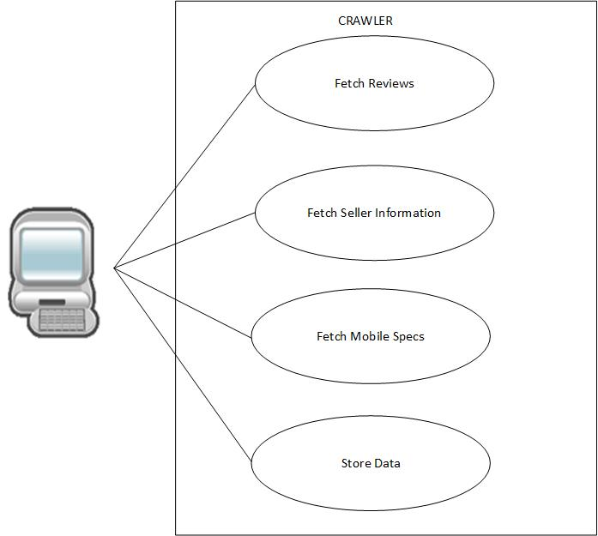

Figure “CRAWLER” Use Case Diagram

## Use Case Description

### Search Mobile

|  |  |  |
| --- | --- | --- |
| **Use Case ID:** | UC01 | |
| **Use Case Name:** | Search Mobile | |
| **Actors:** | | User |
| **Description:** | | User would get information about the searched mobile brand. |
| **Trigger:** | | User click on search button. |
| **Preconditions:** | | User is to present on the Home page. |
| **Postconditions:** | | User will see intended mobiles |
| **Normal Flow:** | | User will type mobile name in search bar  User will click on search button. |
| **Alternative Flows:** | | User can apply feature based filter to search for particular mobile. |
| **Exceptions:** | | If user types invalid mobile brand name then system would not be able to provide information about that brand. |
| **Includes:** | | N/A |
| **Assumptions:** | | User knows the mobile name. |
| **Notes and Issues:** | | N/A |

### View Mobile Model

|  |  |  |
| --- | --- | --- |
| **Use Case ID:** | UC02 | |
| **Use Case Name:** | View Mobile Model | |
| **Actors:** | | User |
| **Description:** | | User will be able to view mobile models. |
| **Trigger:** | | User will select category or would type in search bar |
| **Preconditions:** | | User need to be on Home page. |
| **Post-conditions:** | | User will see mobile models |
| **Normal Flow:** | | User will type mobile brand name in search bar.  User can also select mobile brand name from given brand category.  User will click on search button.  User will see category of mobile. |
| **Alternative Flows:** | | N/A |
| **Exceptions:** | | If user types invalid mobile brand name then system would not be able to provide information about that brand. |
| **Includes:** | | N/A |
| **Assumptions:** | | N/A |
| **Notes and Issues:** | | N/A |

### Make Comparison

|  |  |  |
| --- | --- | --- |
| **Use Case ID:** | UC03 | |
| **Use Case Name:** | Make Comparison | |
| **Actors:** | | User |
| **Description:** | | User will select mobile phones to see comparison of selected mobiles. |
| **Trigger:** | | User will click on comparison button. |
| **Preconditions:** | | User need to select at least two mobile models. |
| **Post-conditions:** | | User will see a result of comparison of mobile model |
| **Normal Flow:** | | User will click on a mobile model  User will select mobile model for comparison  User will click on another mobile model  User will select it also for comparison  User will click on compare button. |
| **Alternative Flows:** | | N/A |
| **Exceptions:** | | If user does not select mobile model and clicks on comparison button to see result of comparison. |
| **Includes:** | | N/A |
| **Assumptions:** | | N/A |
| **Notes and Issues:** | | N/A |

### View Feature Rating

|  |  |  |
| --- | --- | --- |
| **Use Case ID:** | UC04 | |
| **Use Case Name:** | View Feature Rating | |
| **Actors:** | | User |
| **Description:** | | User will be able to see a visualized reviews of other users about the product. |
| **Trigger:** | | User will click on mobile model |
| **Preconditions:** | | User is to present on the Home page. |
| **Post-conditions:** | | User will see desired mobiles |
| **Normal Flow:** | | User will click on mobile model  User will see visualized review |
| **Alternative Flows:** | | N/A |
| **Exceptions:** | | N/A |
| **Includes:** | | N/A |
| **Assumptions:** | | User knows name of features |
| **Notes and Issues:** | | N/A |

### View Seller Information

|  |  |  |
| --- | --- | --- |
| **Use Case ID:** | UC05 | |
| **Use Case Name:** | View Seller Information | |
| **Actors:** | | User |
| **Description:** | | User will get information about the seller of the product. |
| **Trigger:** | | User click on mobile image |
| **Preconditions:** | | User is to present on the selected mobile page. |
| **Post-conditions:** | | User will view seller information of the product |
| **Normal Flow:** | | User will click on mobile image.  User will click on seller.  User will get information about its seller. |
| **Alternative Flows:** | | N/A |
| **Exceptions:** | | N/A |
| **Includes:** | | N/A |
| **Assumptions:** | | N/A |
| **Notes and Issues:** | | N/A |

### Make Comments

|  |  |  |
| --- | --- | --- |
| **Use Case ID:** | UC06 | |
| **Use Case Name:** | Make Comments | |
| **Actors:** | | User |
| **Description:** | | User can comment about the mobile model. |
| **Trigger:** | | User clicks on comment section |
| **Preconditions:** | | User is to present on the mobile model page. |
| **Post-conditions:** | | User has made its comment. |
| **Normal Flow:** | | User will click on mobile.  User will click on comment button.  User will post its comment. |
| **Alternative Flows:** | | N/A |
| **Exceptions:** | | N/A |
| **Includes:** | | N/A |
| **Assumptions:** | | User has used the mobile. |
| **Notes and Issues:** | | N/A |

### Get Mobile Recommendation

|  |  |  |
| --- | --- | --- |
| **Use Case ID:** | UC07 | |
| **Use Case Name:** | Get Mobile Recommendation | |
| **Actors:** | | User |
| **Description:** | | System will recommend user a mobile based on selected specs. |
| **Trigger:** | | User will search mobile. |
| **Preconditions:** | | User is to present on the mobile model page. |
| **Post-conditions:** | | User will get a recommended mobile from system |
| **Normal Flow:** | | User will select specifications.  User will click on submit button.  User will get recommended mobile. |
| **Alternative Flows:** | | N/A |
| **Exceptions:** | | N/A |
| **Includes:** | | N/A |
| **Assumptions:** | | User has used the mobile. |
| **Notes and Issues:** | | N/A |

### Send Email

|  |  |  |
| --- | --- | --- |
| **Use Case ID:** | UC08 | |
| **Use Case Name:** | Contact Seller | |
| **Actors:** | | User |
| **Description:** | | User will be able to contact the seller with its provided contact information. |
| **Trigger:** | | User clicks on contact button |
| **Preconditions:** | | User is to present on the mobile model page. |
| **Post-conditions:** | | User will have contacted to seller |
| **Normal Flow:** | | User will see contact detail.  User will contact the seller. |
| **Alternative Flows:** | | N/A |
| **Exceptions:** | | N/A |
| **Includes:** | | N/A |
| **Assumptions:** | | User likes the product and interested in purchasing. |
| **Notes and Issues:** | | N/A |

### Fetch Seller Information

|  |  |  |
| --- | --- | --- |
| **Use Case ID:** | UC09 | |
| **Use Case Name:** | Fetch Seller Information | |
| **Actors:** | | Crawler |
| **Description:** | | Crawler will bring seller information of the product from websites. |
| **Trigger:** | | User clicks on mobile phone model. |
| **Preconditions:** | | User is to present on the mobile model page. |
| **Post-conditions:** | | User will view seller information. |
| **Normal Flow:** | | User will click on mobile.  User will see seller information. |
| **Alternative Flows:** | | N/A |
| **Exceptions:** | | N/A |
| **Includes:** | | N/A |
| **Assumptions:** | | N/A |
| **Notes and Issues:** | | N/A |

### Fetch Reviews

|  |  |  |
| --- | --- | --- |
| **Use Case ID:** | UC10 | |
| **Use Case Name:** | Fetch Reviews | |
| **Actors:** | | Crawler |
| **Description:** | | Crawler will gather reviews from websites into database. |
| **Trigger:** | | Periodically runs after 15 days |
| **Preconditions:** | | 15 days need to be completed |
| **Post-conditions:** | | Database will be updated. |
| **Normal Flow:** | | N/A |
| **Alternative Flows:** | | N/A |
| **Exceptions:** | | N/A |
| **Includes:** | | N/A |
| **Assumptions:** | | User has commented new reviews on websites |
| **Notes and Issues:** | | N/A |

### 

### Fetch Mobile Specifications

|  |  |  |
| --- | --- | --- |
| **Use Case ID:** | UC11 | |
| **Use Case Name:** | Fetch Mobile Specifications | |
| **Actors:** | | Crawler |
| **Description:** | | Crawler will bring mobile phone specification of the mobile phone |
| **Trigger:** | | Periodically runs after 15 days |
| **Preconditions:** | | 15 days need to be completed |
| **Post-conditions:** | | Database will be updated |
| **Normal Flow:** | | N/A |
| **Alternative Flows:** | | N/A |
| **Exceptions:** | | N/A |
| **Includes:** | | N/A |
| **Assumptions:** | | New mobile phone has been launched |
| **Notes and Issues:** | | N/A |

### Store Data

|  |  |  |
| --- | --- | --- |
| **Use Case ID:** | UC12 | |
| **Use Case Name:** | Store Data | |
| **Actors:** | | Crawler |
| **Description:** | | Crawler will bring mobile phone specification of the mobile phone |
| **Trigger:** | | Periodically runs after 15 days |
| **Preconditions:** | | 15 days need to be completed |
| **Post-conditions:** | | Database will be updated |
| **Normal Flow:** | | N/A |
| **Alternative Flows:** | | N/A |
| **Exceptions:** | | N/A |
| **Includes:** | | N/A |
| **Assumptions:** | | New mobile phone has been launched |
| **Notes and Issues:** | | N/A |

## Functionality

### FR01 Data Acquisition

|  |  |
| --- | --- |
| Identifier | FR01 |
| Title | FR01 Data Acquisition |
| Requirement | System will gather data from Website. |
| Source | Stakeholder |
| Rationale | To store data into database |
| Restrictions and Risk | N/A |
| Dependencies | N/A |
| Priority | High |

### FR02 Classify Data

|  |  |
| --- | --- |
| Identifier | FR02 |
| Title | FR02 Classify Data |
| Requirement | System will add classification tag i.e. positive or negative. |
| Source | Stakeholder |
| Rationale | To classify gathered data. |
| Restrictions and Risk | N/A |
| Dependencies | FR01 |
| Priority | High |

### FR03 Rate Features

|  |  |
| --- | --- |
| Identifier | FR03 |
| Title | FR03 Rate Features |
| Requirement | System will rate features of mobile using specific formula. |
| Source | Stakeholder |
| Rationale | To rate all features of mobile |
| Restrictions and Risk | N/A |
| Dependencies | FR02 |
| Priority | High |

### FR04 Visualize Feature

|  |  |
| --- | --- |
| Identifier | FR04 |
| Title | FR04 Visualize Feature |
| Requirement | System will visualize rated features. |
| Source | Stakeholder |
| Rationale | To visualize major features. |
| Restrictions and Risk | N/A |
| Dependencies | FR03 |
| Priority | High |

### FR05 Select Specification

|  |  |
| --- | --- |
| Identifier | FR05 |
| Title | FR05 Select Specification |
| Requirement | User will select specifications from specification section. |
| Source | Stakeholder |
| Rationale | To search mobile. |
| Restrictions and Risk | N/A |
| Dependencies | N/A |
| Priority | High |

### FR06 Reset Field

|  |  |
| --- | --- |
| Identifier | FR06 |
| Title | Reset Field |
| Requirement | System will reset the selected field to default value. |
| Source | Stakeholder |
| Rationale | To select detail of mobile phone again. |
| Restrictions and Risk | N/A |
| Dependencies | FR05 |
| Priority | Low |

### FR07 Validation

|  |  |
| --- | --- |
| Identifier | FR07 |
| Title | Validation |
| Requirement | System will validate the detail entered by user |
| Source | Stakeholder |
| Rationale | To check the detail for any errors |
| Restrictions and Risk | N/A |
| Dependencies | FR05 |
| Priority | High |

### FR08 Query Submission

|  |  |
| --- | --- |
| Identifier | FR08 |
| Title | FR08 Query Submission |
| Requirement | System will check the detail in database. |
| Source | Stakeholder |
| Rationale | To display existing mobile. |
| Restrictions and Risk | N/A |
| Dependencies | FR05 |
| Priority | High |

### FR09 Process Submitted Query

|  |  |
| --- | --- |
| Identifier | FR09 |
| Title | FR09 Process Submitted Query |
| Requirement | System will process the search query |
| Source | Stakeholder |
| Rationale | To generate result against the query |
| Restrictions and Risk | N/A |
| Dependencies | FR08 |
| Priority | Medium |

### FR10 Query Response

|  |  |
| --- | --- |
| Identifier | FR10 |
| Title | FR10 Query Response |
| Requirement | System will display the matching mobile |
| Source | Stakeholder |
| Rationale | To enable the user to view mobiles. |
| Restrictions and Risk | N/A |
| Dependencies | FR09 |
| Priority | Medium |

### FR11 Enter Model Name

|  |  |
| --- | --- |
| Identifier | FR11 |
| Title | FR11 Enter Model Name |
| Requirement | User will enter model name in search bar and know model name. |
| Source | Stakeholder |
| Rationale | To search mobile with its model name. |
| Restrictions and Risk | N/A |
| Dependencies | N/A |
| Priority | High |

### FR12 Submit Query

|  |  |
| --- | --- |
| Identifier | FR12 |
| Title | FR12 Submit Query |
| Requirement | User should know the model name |
| Source | Stakeholder |
| Rationale | To search mobile with its model name. |
| Restrictions and Risk | N/A |
| Dependencies | FR11 |
| Priority | Medium |

### FR13 Query Processing

|  |  |
| --- | --- |
| Identifier | FR13 |
| Title | FR13 Query Processing |
| Requirement | System will search the query |
| Source | Stakeholder |
| Rationale | To search mobile with its model name. |
| Restrictions and Risk | N/A |
| Dependencies | FR12 |
| Priority | Medium |

### FR14 Display Result

|  |  |
| --- | --- |
| Identifier | FR14 |
| Title | Display Result |
| Requirement | System will display the mobile with matching title |
| Source | Stakeholder |
| Rationale | To search mobile with its model name. |
| Restrictions and Risk | N/A |
| Dependencies | FR11,FR12,FR13 |
| Priority | High |

### FR15 Compare Result

|  |  |
| --- | --- |
| Identifier | FR15 |
| Title | FR15 Compare Result |
| Requirement | System will query to database |
| Source | Stakeholder |
| Rationale | To get comparison result |
| Restrictions and Risk | N/A |
| Dependencies | FR05 |
| Priority | High |

### FR16 Validation

|  |  |
| --- | --- |
| Identifier | FR16 |
| Title | FR16 Validation |
| Requirement | System will validate intended query. |
| Source | Stakeholder |
| Rationale | To validate query |
| Restrictions and Risk | N/A |
| Dependencies | FR05, FR09,FR15 |
| Priority | High |

### FR17 Compare Records

|  |  |
| --- | --- |
| Identifier | FR17 |
| Title | FR17 Compare Records |
| Requirement | System will compare model with other system. |
| Source | Stakeholder |
| Rationale | To compare model |
| Restrictions and Risk | N/A |
| Dependencies | FR05, FR09, FR16 |
| Priority | High |

### FR18 System Response

|  |  |
| --- | --- |
| Identifier | FR18 |
| Title | FR18 System Response |
| Requirement | System will response to the query. |
| Source | Stakeholder |
| Rationale | To view recommended model by system. |
| Restrictions and Risk | N/A |
| Dependencies | FR17 |
| Priority | High |

### FR19 Select Mobile Model

|  |  |
| --- | --- |
| Identifier | FR19 |
| Title | FR19 Select Mobile Model |
| Requirement | User will select mobile model |
| Source | Stakeholder |
| Rationale | To compare mobile model. |
| Restrictions and Risk | N/A |
| Dependencies | N/A |
| Priority | Medium |

### FR20 Compare Model

|  |  |
| --- | --- |
| Identifier | FR20 |
| Title | FR20 Compare Model |
| Requirement | System will compare this model with other models |
| Source | Stakeholder |
| Rationale | To display comparison of mobile |
| Restrictions and Risk | N/A |
| Dependencies | FR19 |
| Priority | High |

### FR21 View Comparison

|  |  |
| --- | --- |
| Identifier | FR21 |
| Title | FR21 View Comparison |
| Requirement | System will display result |
| Source | Stakeholder |
| Rationale | User will view comparison result |
| Restrictions and Risk | N/A |
| Dependencies | FR19 |
| Priority | High |

### FR22 View Model

|  |  |
| --- | --- |
| Identifier | FR22 |
| Title | FR22 View Model |
| Requirement | System will display mobile model |
| Source | Stakeholder |
| Rationale | User will view mobile model |
| Restrictions and Risk | N/A |
| Dependencies | N/A |
| Priority | High |

### FR23 View Specs

|  |  |
| --- | --- |
| Identifier | FR23 |
| Title | FR23 View Specs |
| Requirement | System will display specs of mobile model |
| Source | Stakeholder |
| Rationale | User will view specs of mobile model |
| Restrictions and Risk | N/A |
| Dependencies | FR05 |
| Priority | High |

### FR24 View Feature Rating

|  |  |
| --- | --- |
| Identifier | FR24 |
| Title | FR24 View Feature Rating |
| Requirement | System will display feature rating of mobile model |
| Source | Stakeholder |
| Rationale | User will view feature rating of mobile model |
| Restrictions and Risk | N/A |
| Dependencies | FR03,FR05 |
| Priority | High |

### FR25 View Seller Information

|  |  |
| --- | --- |
| Identifier | FR25 |
| Title | FR25 View Seller Information |
| Requirement | System will display seller information. |
| Source | Stakeholder |
| Rationale | User will view seller information |
| Restrictions and Risk | N/A |
| Dependencies | FR05,FR11 |
| Priority | High |

### FR26 Add Comment

|  |  |
| --- | --- |
| Identifier | FR26 |
| Title | FR26 Add Comment |
| Requirement | System will add new comment into database |
| Source | Stakeholder |
| Rationale | To add new comment |
| Restrictions and Risk | N/A |
| Dependencies | N/A |
| Priority | Medium |

### FR27 View Comments

|  |  |
| --- | --- |
| Identifier | FR27 |
| Title | FR27 View Comments |
| Requirement | User will view comments |
| Source | Stakeholder |
| Rationale | View Model comments |
| Restrictions and Risk | N/A |
| Dependencies | N/A |
| Priority | Medium |

## Non – Functional Requirements

### Usability

|  |  |
| --- | --- |
| Identifier | ***NFR1*** |
| Title | Usability |
| Requirement | Because of user friendly interfaces, Beginner user will have self-explanatory interface and can understand the requirements easily.  User can perform all the functions on the system with the help of mouse only.  It is possible to reach any given system function from the main window in less than 3 clicks. |

### 

### Performance

|  |  |
| --- | --- |
| Identifier | ***NFR4*** |
| Title | Performance |
| Requirement | System should response to 500 queries in less than 10 seconds.  System response time shall not be greater than 4 seconds against the user requests.  The information is updated at regular intervals whenever any new information comes(i.e. new mobile model) |

### Reliability

|  |  |
| --- | --- |
| Identifier | ***NFR7*** |
| Title | Reliability |
| Requirement | The down time of system would be less than 1 hour per 5 months.  The system recover time in case of minor error if occurred shall not exceeds 10 minutes. |

### Security

|  |  |
| --- | --- |
| Identifier | ***NFR9*** |
| Title | Security |
| Requirement | Only authorize persons will access the database granted privileges, username and password. |

### Availability

|  |  |
| --- | --- |
| Identifier | ***NFR10*** |
| Title | Availability |
| Requirement | System shall be operational 24 hours a day 7 days a week.  The database backup will be maintained so that system will work in case any error in Master database. |

## User Interfaces

Figure 3 Interface

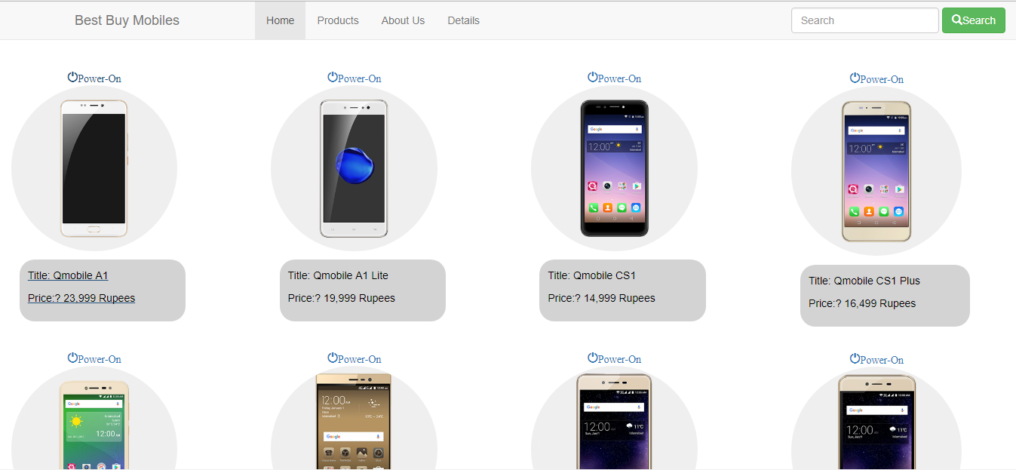

Figure 4 Interface

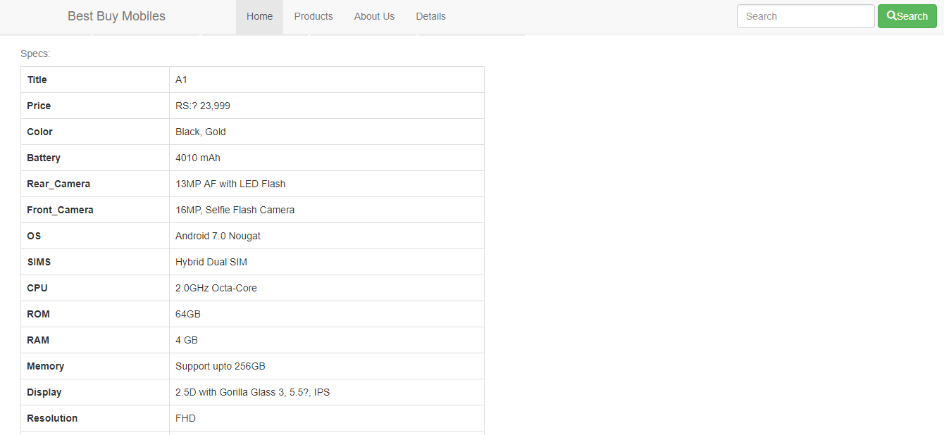

Figure 5 Interface

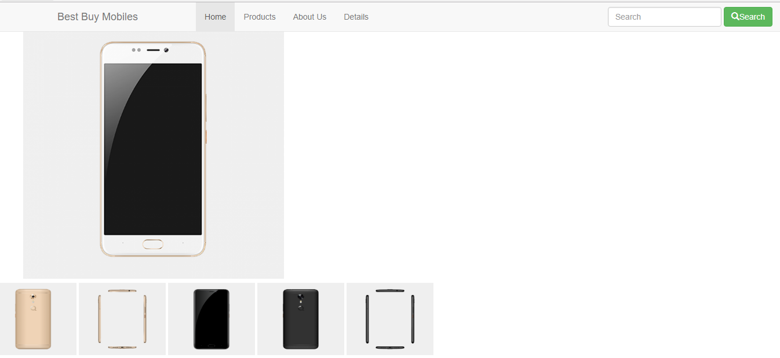

Figure 6 Interface

# Project Gantt chart

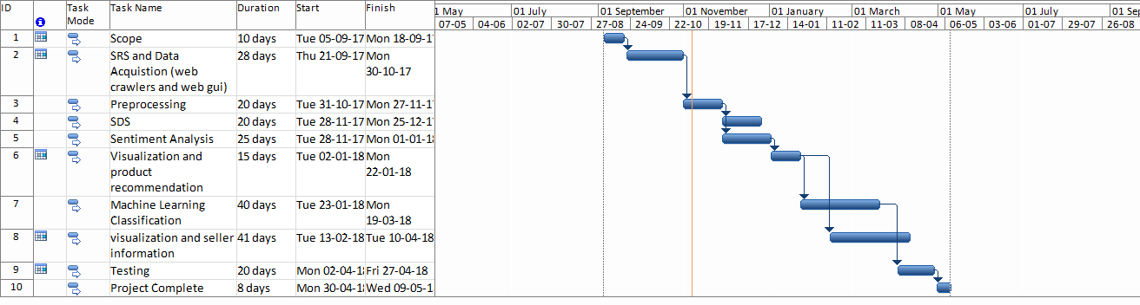

Figure 7 Gantt Chart